**VISVESVARAYA TECHNOLOGICAL UNIVERSITY**

"Jnana Sangama", Belagavi : 590018

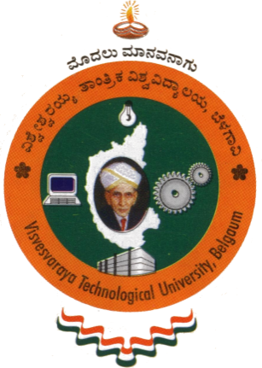

A Project report on

**CALLIFY: VIDEO CONFERENCING APPLICATION**

Submitted in partial fulfillment of the requirement for the award of the degree of

**Bachelor of Engineering**

**in**

**Computer Science and Engineering**

by

**Dalavai Hruday 1AY21CS049**

Under the guidance of

**Prof. Prashanth Kumar S P**

Assistant Professor

|  |  |
| --- | --- |
| |  | | --- | |  | |

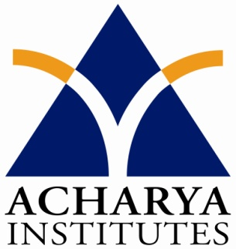

**DEPARTMENT OF COMPUTER SCIENCE & ENGINEERING**

**ACHARYA INSTITUTE OF TECHNOLOGY**

(Affiliated to Visvesvaraya Technological University, Belgaum)

**2024-2025**

**ACHARYA INSTITUTE OF TECHNOLOGY**

Acharya Dr. Sarvepalli Radhakrishnan Road, Soladevanahalli, Bangalore – 560107

(Affiliated to Visvesvaraya Technological University, Belagavi)

**DEPARTMENT OF COMPUTER SCIENCE & ENGINEERING**



**Certificate**

Certified that the Project entitled **“CALLIFY: VIDEO CONFERENCING APPLICATION”** is a Bonafide work carried out by **Dalavai Hruday (1AY21CS049)** in partial fulfillment for the award of degree of **Bachelor of Engineering in Computer Science & Engineering of Visvesvaraya Technological University**, Belagavi during the year **2024-2025.** It is certified that all corrections/ suggestions indicated for internal assessments have been incorporated in the Report deposited in the departmental library. The project report has been approved as it satisfies the academic requirements in respect of project prescribed for the **Bachelor of Engineering Degree**.

­­­­––––––––––––––– ––––––––––––––––– ––––––––––––––––

Signature of Guide Signature of the HOD Signature of the principal

**Prof. Prashanth Kumar Prof. Rajeev Bilagi Dr. Rajeswari**

**S P**

**Assistant Professor**

|  |  |  |  |
| --- | --- | --- | --- |
| **External Viva** | | | |
|  | **Name of the Examiners** |  | **Signature with Date** |
|  |  |  |  |
|  |  |  |  |

**DECLARATION**

I ,Dalavai Hruday (USN – 1AY21CS049), students of B.E, Computer Science and Engineering, Acharya Institute of Technology, Bengaluru-107, hereby declare that the project entitled "Callify : Video Conferencing Application" is an authentic record of our own work carried out under the supervision and guidance of Prof. Prashanth Kumar S P, Assistant Professor Department of Computer Science and Engineering, Acharya Institute of Technology, Bengaluru. We have not submitted the matter embodied to any other University or Institution for the award of any other degree.

Date: 19/12/2024

Place: Bengaluru

Dalavai Hruday USN 1AY21CS049

**ACKNOWLEDGEMENT**

We express our gratitude to our institution and management for providing us with good infrastructure, laboratory, facilities and inspiring staff, and whose gratitude was of immense help in completion of this report successfully.

We are deeply indebted to **Dr.  Rajeswari** Principal, Acharya Institute of Technology, Bangalore, who has been a constant source of enthusiastic inspiration to steer us forward.

We sincerely thank our respected Vice-Principal, **Prof. Marigowda C K**, for his invaluable guidance, support, and encouragement throughout this project.

We heartily thank **Prof. Rajeev Bilagi**, Head of the Department, Department of Computer Science and Engineering, Acharya Institute of Technology Bangalore, for his valuable support and for rendering us resources for this project work.

We specially thank **Mr. Prashanth Kumar S P**, Assistant Professor, Department of Computer Science and Engineering who guided us with valuable suggestions in completing this project at every stage.

Also, we wish to express deep sense of gratitude for project coordinator **Mr. Prashanth Kumar S P**, Assistant Professor, **Mr. Gowtham Raj** **M**, Assistant Professor, Department of Computer Science and Engineering, Acharya Institute of Technology for his support and advice during the course of this project.

We would like to express our sincere thanks and heartfelt gratitude to our beloved Parents, Respected Professors, Classmates, Friends, and juniors for their indispensable help at all times.

Last but not the least our respectful thanks to the Almighty.

**Dalavai Hruday (1AY21CS049)**